**IOT_Phase3**

**(Smart Water Management)**

**Team Members:**

1. V Santhoshkumar(210621106046)
2. P Giridharan(210621106020)
3. Prithiviraj T K(210621106040)
4. Lathesh M(210621106031)
5. Madhan S(210621106033)

**Introduction**

Water is a finite and essential resource, and its efficient management is vital for meeting the growing demands of urbanization while preserving the environment. Smart water management involves the integration of technology, data analytics, and innovative solutions to optimize water distribution, reduce waste, and improve water quality.

**Objectives**

- To understand the importance of smart water management in the context of sustainable development.

- To analyse existing literature and case studies on smart water management.

- To identify relevant technologies for efficient water management.

- To outline implementation strategies for smart water systems.

- To evaluate the benefits and challenges associated with smart water management.

**Literature Review**

This section provides an in-depth review of the existing literature, including research papers, reports, and case studies on smart water management. It discusses the global significance of water management, the role of technology, and key challenges.

**Methodology**

The research methodology involves a combination of quantitative and qualitative approaches. Data collection includes surveys, interviews, and data analysis, with a focus on understanding the current water management practices in urban areas.

**Data Collection and Analysis**

This section details the data collection process and presents the findings. It provides insights into current water usage patterns and challenges faced in water management.

**Technologies for Smart Water Management**

The report explores various technologies such as IoT sensors, data analytics, and remote monitoring that play a crucial role in smart water management systems.

**Implementation Strategies**

This section outlines strategies for the implementation of smart water management systems, including infrastructure development, policy changes, and public awareness campaigns.

**Simulation Code**

#define PIN_TRIG 26

#define PIN_ECHO 25

#define LOWLED 18

#define MIDLED 19

#define HIGHLED 21

#define MOTOR 27

Unsigned int level = 0;

Void setup() {

pinMode(LOWLED, OUTPUT);

pinMode(MIDLED, OUTPUT);

pinMode(HIGHLED, OUTPUT);

pinMode(MOTOR, OUTPUT);

digitalWrite(LOWLED, HIGH);

digitalWrite(MIDLED, HIGH);

digitalWrite(HIGHLED, HIGH);

digitalWrite(MOTOR, LOW);

Serial.begin(115200);

pinMode(PIN_TRIG, OUTPUT);

pinMode(PIN_ECHO, INPUT);

}

Void loop() {

// Start a new measurement:

digitalWrite(PIN_TRIG, HIGH);

delayMicroseconds(10);

digitalWrite(PIN_TRIG, LOW);

// Read the result:

Int duration = pulseIn(PIN_ECHO, HIGH);

Serial.print(“Distance in CM: “);

Serial.println(duration / 58);

Serial.print(“Distance in inches: “);

Serial.println(duration / 148);

Level = (duration / 10);

If(level < 100)

{

digitalWrite(LOWLED, LOW);

digitalWrite(MOTOR, HIGH);

digitalWrite(HIGHLED, HIGH);

digitalWrite(MIDLED, HIGH);

}

Else if ((level > 200 ) && (level < 400))

{

digitalWrite(LOWLED, HIGH);

digitalWrite(HIGHLED, HIGH);

digitalWrite(MIDLED, LOW);

}

Else if (level >= 400 )

{

digitalWrite(HIGHLED, LOW);

digitalWrite(MIDLED, HIGH);

digitalWrite(LOWLED, HIGH);

digitalWrite(MOTOR, LOW);

}

Delay(1000);

}

**Simulation Link**

[**https://wokwi.com/projects/378842842883994625**](https://wokwi.com/projects/378842842883994625)

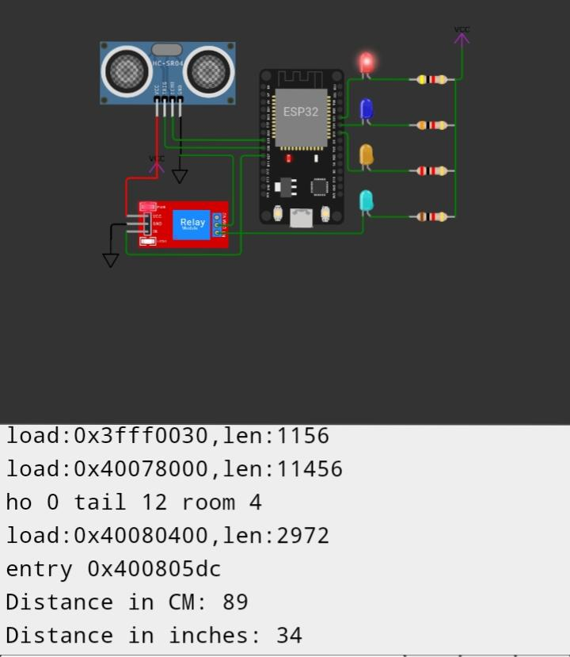

**Benefits and Challenges**

The report discusses the benefits of smart water management, including water conservation, cost savings, and improved water quality. It also addresses the challenges, such as data security and infrastructure investments.

**Conclusion**

The conclusion summarizes the key findings and emphasizes the importance of embracing smart water management to address water scarcity and environmental concerns.